## Risk Impact Image result for probability vs impact matrix

## Timeline Pekerjaan

| **No** | **Aktivitas** | **Durasi** | **Downtime** | **Status** |
| --- | --- | --- | --- | --- |
| **-** | **Capture before commands :**  CORE: (PSC-CO-EM)  Show run  Show ip interface brief  Show interface description  Show version  Show platform  Show ip ospf neighbor  Show ip ospf interface brief  Show bfd neighbor  Show bfd neighbor detail  Show mpls ldp neighbor  Show mpls ldp interface  Show mpls ldp discovery  Show mpls forwarding  Show bgp vpnv4 unicast all summary  Show bgp vpnv4 unicast all  Show ip route vrf VPN-UKER  Capture sh running to harddisk for fallback plan :  Copy running-config harddisk:running-config-backup-modify-bgp-parameter-fiberstar-mpls | 15 menit | No |  |
| **1** | **Modify Parameter BGP Fiberstar MPLS on PSC-CO-EM2** | 15 menit | No |  |
| Configure prefix-list |  |  |  |
| Configure route-map |  |  |  |
| Configure BGP for Fiberstar peer |  |  |  |
| Verification |  |  |  |
| *Fallback if necessary* |  |  |  |
| **2** | **Modify Parameter BGP Fiberstar MPLS on PSC-CO-EM1** | 15 menit | No |  |
| Configure prefix-list |  |  |  |
| Configure route-map |  |  |  |
| Configure BGP for Fiberstar peer |  |  |  |
| Verification |  |  |  |
| *Fallback if necessary* |  |  |  |
| **-** | **Capture after commands :**  PSC-CO-EM :  Show run  Show ip interface brief  Show interface description  Show version  Show platform  Show ip ospf neighbor  Show ip ospf interface brief  Show bfd neighbor  Show bfd neighbor detail  Show mpls ldp neighbor  Show mpls ldp interface  Show mpls ldp discovery  Show mpls forwarding  Show bgp vpnv4 unicast all summary  Show bgp vpnv4 unicast all  Show ip route vrf VPN-UKER | 15 menit | No |  |
|  | **Monitoring** | 30 menit | No |  |

**Topology**

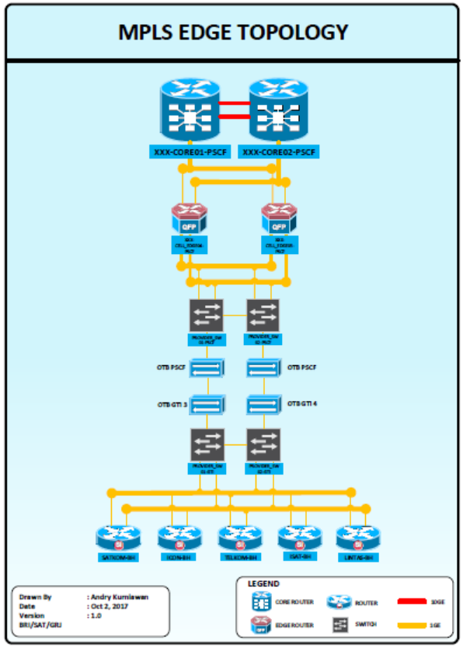

**PSC-CO-EM2**

1. **Konfigurasi pada perangkat Router PSC-CO-EM2**

|  |  |
| --- | --- |
| **No** | **Command Task** |
| 01 | **Modify Parameter BGP Fiberstar MPLS on PSC-CO-EM2** |
| **PSC-CO-EM2** | |
| 1. **Configure Prefix-list**   conf t  !  ip prefix-list PRIMARY-UKER-MPLS-OVER-VSAT-FIBERSTAR seq 9999 deny 0.0.0.0/0 le 32    Verification :  Show run | s prefix-list PRIMARY-UKER-MPLS-OVER-VSAT-FIBERSTAR   1. **Configure Route-map**   **!**  **route-map IN-P2-FIBERSTAR-MPLS-STB-V1 deny 10**  **match ip address prefix-list DC_PREFIX_TO_BH**  **route-map IN-P2-FIBERSTAR-MPLS-STB-V1 deny 20**  **match ip address prefix-list LEAK_PREFIX_DC**  **route-map IN-P2-FIBERSTAR-MPLS-STB-V1 deny 30**  **match ip address prefix-list FIBERSTAR_MPLS_PREFIX_BLK**  **route-map IN-P2-FIBERSTAR-MPLS-STB-V1 permit 40**  **match ip address prefix-list PRIMARY-UKER-MPLS-OVER-VSAT-FIBERSTAR**  **set local-preference 233**  **route-map IN-P2-FIBERSTAR-MPLS-STB-V1 permit 50**  **set local-preference 180**  **!**  **route-map OUT-P2-FIBERSTAR-MPLS-STB-V1 permit 10**  **match ip address prefix-list DC_PREFIX_TO_BH**  **set metric 70**  **!**  Verification :  Show run | s route-map IN-P2-FIBERSTAR-MPLS-STB-V1  Show run | s route-map OUT-P2-FIBERSTAR-MPLS-STB-V1  Show route-map IN-P2-FIBERSTAR-MPLS-STB-V1  Show route-map OUT-P2-FIBERSTAR-MPLS-STB-V1   1. **Configure BGP for Fiberstar peer**   !  router bgp 65000  address-family ipv4 uni vrf VPN-UKER  neighbor 172.31.33.6 shutdown  no neighbor 172.31.33.6 route-map FIBERSTAR-MPLS-IN in  no neighbor 172.31.33.6 route-map FIBERSTAR-MPLS-OUT out  neighbor 172.31.33.6 route-map IN-P2-FIBERSTAR-MPLS-STB-V1 in  neighbor 172.31.33.6 route-map OUT-P2-FIBERSTAR-MPLS-STB-V1 out  no neighbor 172.31.33.6 shutdown  !  Verification :  Show bgp vpnv4 uni vrf VPN-UKER neighbor 172.31.33.6  Show bgp vpnv4 uni vrf VPN-UKER neighbor 172.31.33.6 route  Show bgp vpnv4 uni vrf VPN-UKER neighbor 172.31.33.6 advertise-route  Show bgp all sum | in 172.31.33.6 | |
|  | |

**PSC-CO-EM1**

1. **Konfigurasi pada perangkat Router PSC-CO-EM1**

|  |  |
| --- | --- |
| **No** | **Command Task** |
| 02 | **Modify Parameter BGP Fiberstar MPLS on PSC-CO-EM1** |
| **PSC-CO-EM1** | |
| 1. **1. Configure Prefix-list**   conf t  !  ip prefix-list PRIMARY-UKER-MPLS-OVER-VSAT-FIBERSTAR seq 9999 deny 0.0.0.0/0 le 32    Verification :  Show run | s prefix-list PRIMARY-UKER-MPLS-OVER-VSAT-FIBERSTAR   1. **Configure Route-map**   **!**  **route-map IN-P2-FIBERSTAR-MPLS-ACT-V1 deny 10**  **match ip address prefix-list DC_PREFIX_TO_BH**  **route-map IN-P2-FIBERSTAR-MPLS-ACT-V1 deny 20**  **match ip address prefix-list LEAK_PREFIX_DC**  **route-map IN-P2- FIBERSTAR-MPLS-ACT-V1 deny 30**  **match ip address prefix-list FIBERSTARKOM_MPLS_PREFIX_BLK**  **route-map IN-P2-FIBERSTAR-MPLS-ACT-V1 permit 40**  **match ip address prefix-list PRIMARY-UKER-MPLS-OVER-VSAT-FIBERSTAR**  **set local-preference 235**  **route-map IN-P2-FIBERSTAR-MPLS-ACT-V1 permit 50**  **set local-preference 190**  **!**  **route-map OUT-P2-FIBERSTAR-MPLS-ACT-V1 permit 10**  **match ip address prefix-list DC_PREFIX_TO_BH**  **set metric 60**  **!**  Verification :  Show run | s route-map IN-P2-FIBERSTAR-MPLS-ACT-V1  Show run | s route-map OUT-P2-FIBERSTAR-MPLS-ACT-V1  Show route-map IN-P2-FIBERSTAR-MPLS-ACT-V1  Show route-map OUT-P2-FIBERSTAR-MPLS-ACT-V1   1. **Configure BGP for Fiberstar peer**   !  router bgp 65000  address-family ipv4 uni vrf VPN-UKER  neighbor 172.31.33.2 shutdown  no neighbor 172.31.33.2 route-map FIBERSTAR-MPLS-IN in  no neighbor 172.31.33.2 route-map FIBERSTAR-MPLS-OUT out  neighbor 172.31.33.2 route-map IN-P2-FIBERSTAR-MPLS-ACT-V1 in  neighbor 172.31.33.2 route-map OUT-P2-FIBERSTAR-MPLS-ACT-V1 out  no neighbor 172.31.33.2 shutdown  !  Verification :  Show bgp vpnv4 uni vrf VPN-UKER neighbor 172.31.33.2  Show bgp vpnv4 uni vrf VPN-UKER neighbor 172.31.33.2 route  Show bgp vpnv4 uni vrf VPN-UKER neighbor 172.31.33.2 advertise-route  Show bgp all sum | in 172.31.33.2 | |
|  | |

# <> Fallback Plan

Bagian ini menjelaskan detail skenario fallback jika integrasi dari perangkat core to router mx-480 tidak berjalan sesuai dengan yang diharapkan :

1. Lakukan fallback dengan mengembalikan konfigurasi pada checkpoint yang sudah disimpan sebelum aktifitas dimulai :

|  |  |
| --- | --- |
| **No** | **Command Task** |
| 01 | Fallback scenario to previously saved config |
| **PSC-CO-EM1 & PSC-CO-EM2** | |
| 1. Pada node PSC-CO-EM lakukan perintah di bawah ini untuk mengembalikan konfig ke sesi sebelum integrasi :   PSC-CO-EM1#configure replace harddisk:running-config-backup-modify-bgp-parameter-fiberstar-mpls list  This will apply all necessary additions and deletions  to replace the current running configuration with the  contents of the specified configuration file, which is  assumed to be a complete configuration, not a partial  configuration. Enter Y if you are sure you want to proceed. ? [no]: yes  Apr 5 02:10:13.199: Rollback:Acquired Configuration lock.  Apr 5 09:10:13 WIB: %SYS-5-CONFIG_R: Config Replace is Done  !Pass 1  !List of Rollback Commands:  interface Loopback1000  no ip address 111.111.111.111 255.255.255.255  no interface Loopback1000  end  Total number of passes: 1  Rollback Done  BSC-CO-CR1#  Apr 5 09:10:16 WIB: %LINEPROTO-5-UPDOWN: Line protocol on Interface Loopback1000, changed state to down  Apr 5 09:10:16 WIB: %LINK-5-CHANGED: Interface Loopback1000, changed state to administratively down  PSC-CO-EM1# | |